Andrew Stringer
D205 – Data Acquisition
8/23/2024
WGU

A, Question
- Which customers have a fiber optic internet service and pay less than $120 a month?

A1, Question Justification
- To answer the question above, a new table (services) will be created and then the data from the Services.csv file will be copied into the services table. There is a column (InternetService) that contains what type of internet service a customer has. Using the customer_id column I will join the customer and services tables and select the customer ID, the internet service, and the monthly charge to display the answer to the above question.

A2, Identifying Data
- From original database: churn database, customer table, customer_id (text data type) column and monthly_charge (numeric data type) column.
- From add-on Services.csv: customer_id (text data type) column and InternetService (text data type) column.

B, Entity Relationship Diagram
- 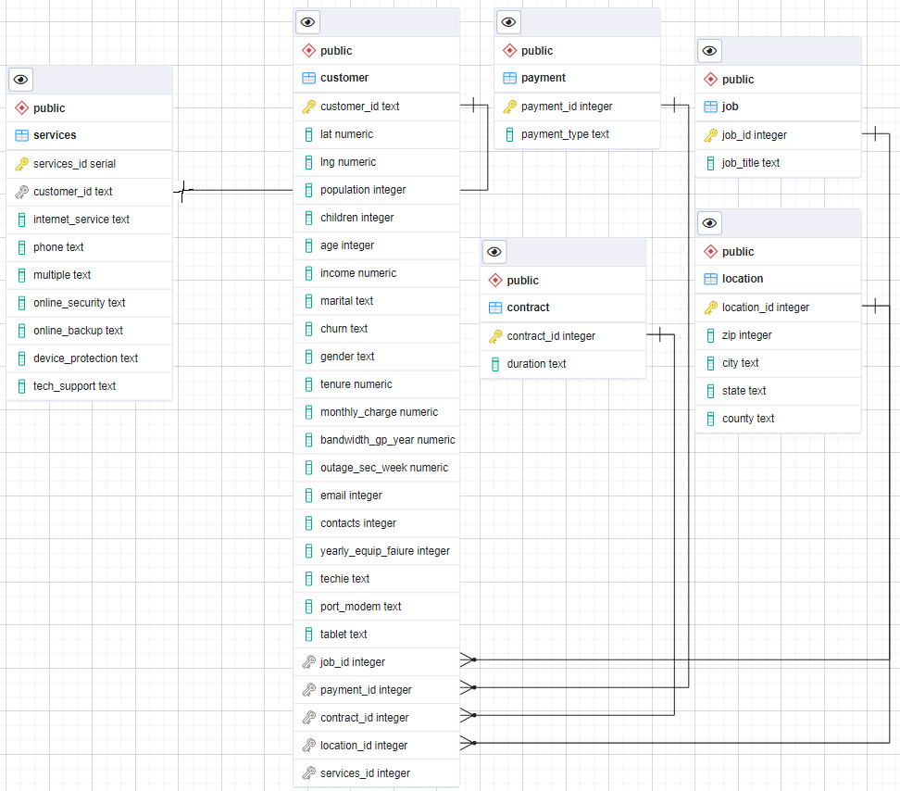
- I couldn’t get pgAdmin to show a 1:1 relationship as it is not supported, source will be below in the Web Sources section.
- Within the services table, services_id is the primary key and the customer_id is referencing the customer_id primary key of the customer table.
- In services, services_id is set to NOT NULL.

B1, Relationship Discussion
- The relationship between customer and the new table, services, is one-to-one. One customer will have one combination of services, and each combination of services will belong to one customer.
- As pointed out above, the ERD didn’t show a 1:1 relationship so I used Microsoft Paint to change it.

B2, Statement for the ERD
- CREATE TABLE services (
services_id SERIAL PRIMARY KEY,
customer_id text REFERENCES customer(customer_id),
internet_service text,
phone text,
multiple text,
online_security text,
online_backup text,
device_protection text,
tech_support text
);

B3, Loading CSV Data
- COPY services (
customer_id,
internet_service,
phone,
multiple,
online_security,
online_backup,
device_protection,
tech_support
)
FROM ‘C:\LabFiles\Services.csv’
DELIMITER ‘,’
CSV HEADER;

C, SQL Query
- SELECT c.customer_id AS customer,
s.internet_service AS internet_service,
ROUND(c.monthly_charge, 2) AS monthly_charge
FROM customer AS c
INNER JOIN services AS s
ON c.customer_id = s.customer_id
WHERE s.internet_service = ‘Fiber Optic’
AND c.monthly_charge < 120.00;

C1, CSV Files
- Uploaded separately.

D, Add-On File Time Period
- The add-on file should be acquired on the first business day every 3 months (Jan., Apr., Jul., and Oct.) and used to refresh the data in the database the same day.

D1, Explanation of Time Period
- Customers have the option of contracts with the company, so knowing who has a contract coming up for renewal during the quarter is good for the sales department. They can contact the customer before the renewal date to try to add services or have them sign up for a new contract. Refreshing at the beginning of the quarter will also keep data up to date on customers who have become inactive, keeping the data accurate.

E, Panopto Video
- https://wgu.hosted.panopto.com/Panopto/Pages/Viewer.aspx?id=ec173623-d5db-499c-ad7c-b1d600f36f0a

F, Web Sources
- Page, D. (n.d.). ERD Tool — pgAdmin 4 8.11 documentation. https://www.pgadmin.org/docs/pgadmin4/development/erd_tool.html
- PostgreSQL Tutorial. (2024, February 1). Import CSV file into PosgreSQL table. https://www.postgresqltutorial.com/postgresql-tutorial/import-csv-file-into-posgresql-table/

